An ice cream manufacturing plant produces three ice cream flavors: Cookies N’ Cream (C), Mint Chocolate Chip (M), and Vanilla (V). These ice creams can be produced via two different machines. This manufacturing plant has two production machines. Running first machine for an hour costs $400 and yields 300 cups of C ice cream, 100 cups of M ice cream, and 100 cups of V ice cream. Running second machine for an hour costs $100 and yields 100 cups of C ice cream, and 100 cups of M ice cream. To meet customer demands, at least 1000 cups of C ice cream, 500 cups of M ice cream, and 300 cups of M ice cream must be produced daily. Determine the daily production plan that minimizes the cost of meeting the company’s daily demands.

**Discussion**

This problem is straight forward. We can solve number of hours to run machine 1 and machine 2 even without the solver. Machine 2 does not yield Vanilla (V) ice cream, but we have minimum demand of 300 for this flavor. Since this needs to be produced solely by machine 1, we need at least 3 hours of process 1 to meet the demand of this flavor. At this point, because of machine 1 we have 900 cups of Cookies N’ Cream (C) and 300 cups of Mint Chocolate Chip (M). The C ice cream is short of 100 cups and M ice cream is short of 200 cups to meet the daily demand. Running either of the machine once will lead to satisfying demand of C ice cream. Hence, let us focus on satisfying demand of M ice cream (which will consequentially lead to satisfying demand of C ice cream). To produce 200 more cups of M ice cream, either of the processes needs to be run for 2 hours. Running machine 1 for 2 hours costs 800$ and running machine 2 for 2 hours costs 200$. Therefore, we choose to run machine 2 for 2 hours and satisfy demand of M ice cream as well as C ice cream. Consequently, we need 3 hours for running machine 1 and 2 hours of machine 2. But this approach cannot be used for most problems as most business case scenarios are not as simple as this. Excel Solver can be used to solve many types of more complex situations. Let us take a look at how to do this.

Firstly, we need to identify the objective function: minimize production cost given daily demands. This cost is incurred while running production machines. Since we have the hourly cost to run the two machines, our production plan should be such that, in a given day, the combined cost of running the 2 machines to meet demands of three flavors stays in a minimum. That is, the objective is to minimize total cost: (unit cost for running machine 1 * number of hours running machine 1)+(unit cost for running machine 2 * number of hours running machine 2). Our decision variables are number of hours that machine 1 and 2 are run. Next, we must ensure that the daily demands are satisfied.

**Model**

**Parameter**

$C_{i}$ Cost of running machine $i$ for an hour ($ per hour), $i ϵ\{1,2,3\}$

$Y_{ij}$ Yield of flavor $j$ ice cream from running machine $i$ for an hour (cups per hour), $j ϵ\{1,2\}$

$D_{j}$ Daily demand for flavor $j$ ice cream (cups)

**Decision Variable**

$x_{i}$ Number of hours to run machine $i$ in a given day

**Objective Function :** Minimize total cost of running two machines

$$\max_{x_{i}}\left\{\sum_{i=1}^{2}{C_{i}x_{i}} \right\}$$

**Constraints**

1. Non-negativity Constraints

2. Daily demand must be satisfied

**Optimal Solution** is to run machine 1 for 3 hours and run machine 2 for 2 hours, as shown in following figure.

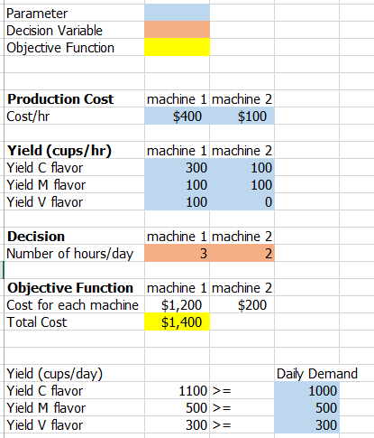

**Sensitivity Analysis**

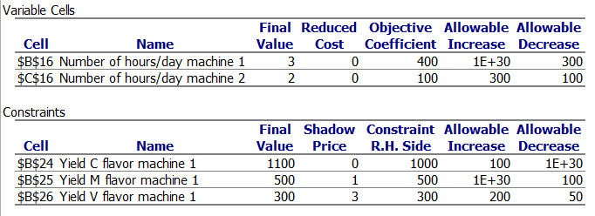

At the optimal decision, we should run machine 1 and 2 for 3 and 2 hours, respectively. Since all of two decision variables are not at its non-negativity constraint, the reduced cost is zero. Objective coefficient represents influence of decision variable to the objective function. For example, if we run an additional hour for machine 1, this incurs marginal production cost by $400. This column gives us a sense of relative importance decision variables to the objective function. Allowable increase/decrease shows sensitivity of objective coefficient. For instance, if production cost per hour of machine 2 increases by $400, from $100 to $500 per hour, this result in change in optimal decision level. The company might consider reduce running hour for machine 2 as operation cost increase beyond allowable increase limit. However, allowable increase boundary for machine1 is very large. This is because, no matter amounts the running cost for machine 1 increases, this will not change the decision that company should run this machine by 3 hours. This is because, machine 1 can not be substituted by machine 2. Only machine 1 can produce the V flavor ice cream. Therefore, decision that the company should run this machine 1 by 3 hours are not sensitive to change in running cost of this machine.

The constraints table, the second table, gives us a sense if we use up all constraint spaces in optimal decision point or not. If we have already used up of our constraint spaces, or available resources, the shadow price would show us how much we are willing to pay to get more relaxing constraint by one unit. For example, shadow price of the first column is zero, which means there is need to relax this daily demand constraint for number of C flavor ice cream. This is because, at the optimal decision, number of cups of C flavor ice cream have already exceeded the minimum demand requirement at 1,000 cups a day. Consequently, shadow price becomes zero and allowable decrease for the first row is significantly large. In other words, the optimal level of C flavor ice cream would always be 1,100 cups a day, no matter how much amount daily demand for C flavor ice cream is reduced. In this case, we have abundance of constraint space left.